*C****urriculum*** *V****itae***

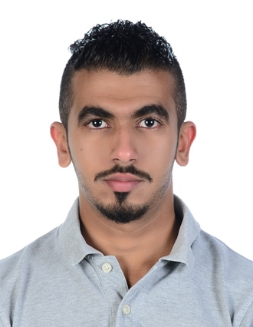

**Personal Information’s:**

**Name: Hasan Mohammed Hasan Alqari**

**Marital Status: Single**

**Birth Date: 4 October 1994**

**Place of Birth: Shakhoura – Bahrain**

**Nationality: Bahraini**

**I.D No. : 941000990**

**Contacts:**

**Mobile No. : +973 36378988**

**E-Mail : hasanalqri@gmail.com**

**------------------------------------------------------------------------------------------------------------------**

**Educational Qualifications:**

* **2012- 2017 Bachelor of Physical Education ( Bahrain University ) .**
* **2011- 2012 Secondary school general certificate ( Ahmed Al- Omran school ).**

**------------------------------------------------------------------------------------------------------------------**

**Languages**

* **Arabic Excellent in reading, speak and writing.**
* **English very good in reading, speaking, and writing.**

**------------------------------------------------------------------------------------------------------------------**

**Personal Skills:**

**1) A motivated employee with effective interpersonal skills, creative mindset and shrewd vision .**

**2) An articulate supportive and persuasive team player and able motivate and communicate to achieve exceptional group performance .**

**3) Ambitious, competent with expceptionally positive attitude.**

**4) Determine to become a good asset to your company, and accustomed to being under work pressure and strain.**

**5) General computer knowledge and using office packages: Word, Excel ……. Etc.**

**6) Fast Typing: (Arabic – English).**

------------------------------------------------------------------------------------------------------------------

**Hobbies:**

1. **Reading Novels**
2. **Football.**

**3) photographing**

**---------------------------------------------------------------------------------------------------**